Annual Report to be submitted to the Provincial Grand Mentor
31st January 2025

Lodge Name: |  | Number:
Lodge Mentor:
Lodge Liaison Officer:

- In relation to the newer members of your Lodge, please indicate with comments if appropriate:

a) | How many such Brethren are currently benefiting from the scheme?
b) | How many of these are attending Lodge of Instruction/Improvement?
c) | How many of these have been introduced to the UGLE Solomon resources and ‘Welcome Modules’?
d) | Are the below guidance booklets (available from the Provincial Office or download from the PGL website) being issued and is the assigned Personal Mentor discussing them with the candidate? And have you registered ALL new members to the members area of the Provincial Website? lincolnshirefreemasons.org  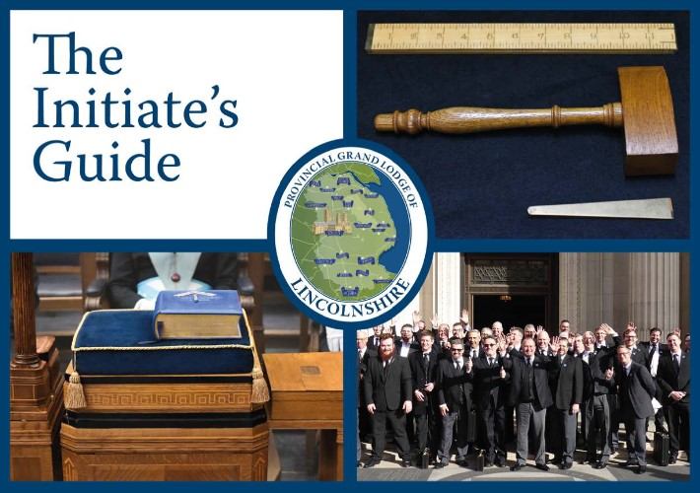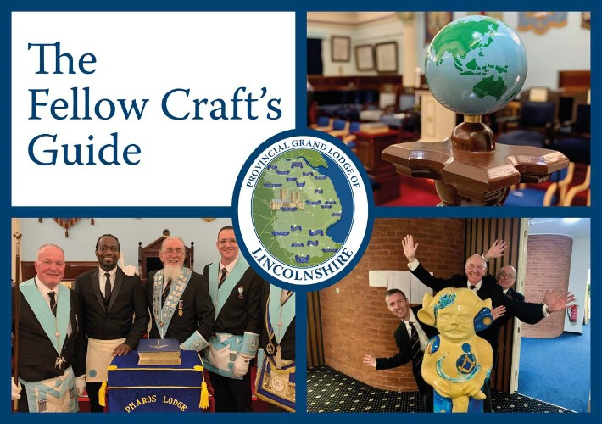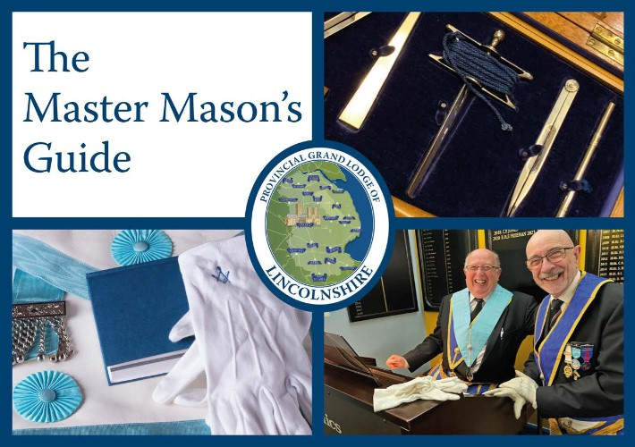
- Additional mentoring in the Lodge.

- Are the below guidance booklets (available from the Provincial Office or download from the PGL website) being issued and discussed with prospective officers of the Lodge and appropriate Brethren?
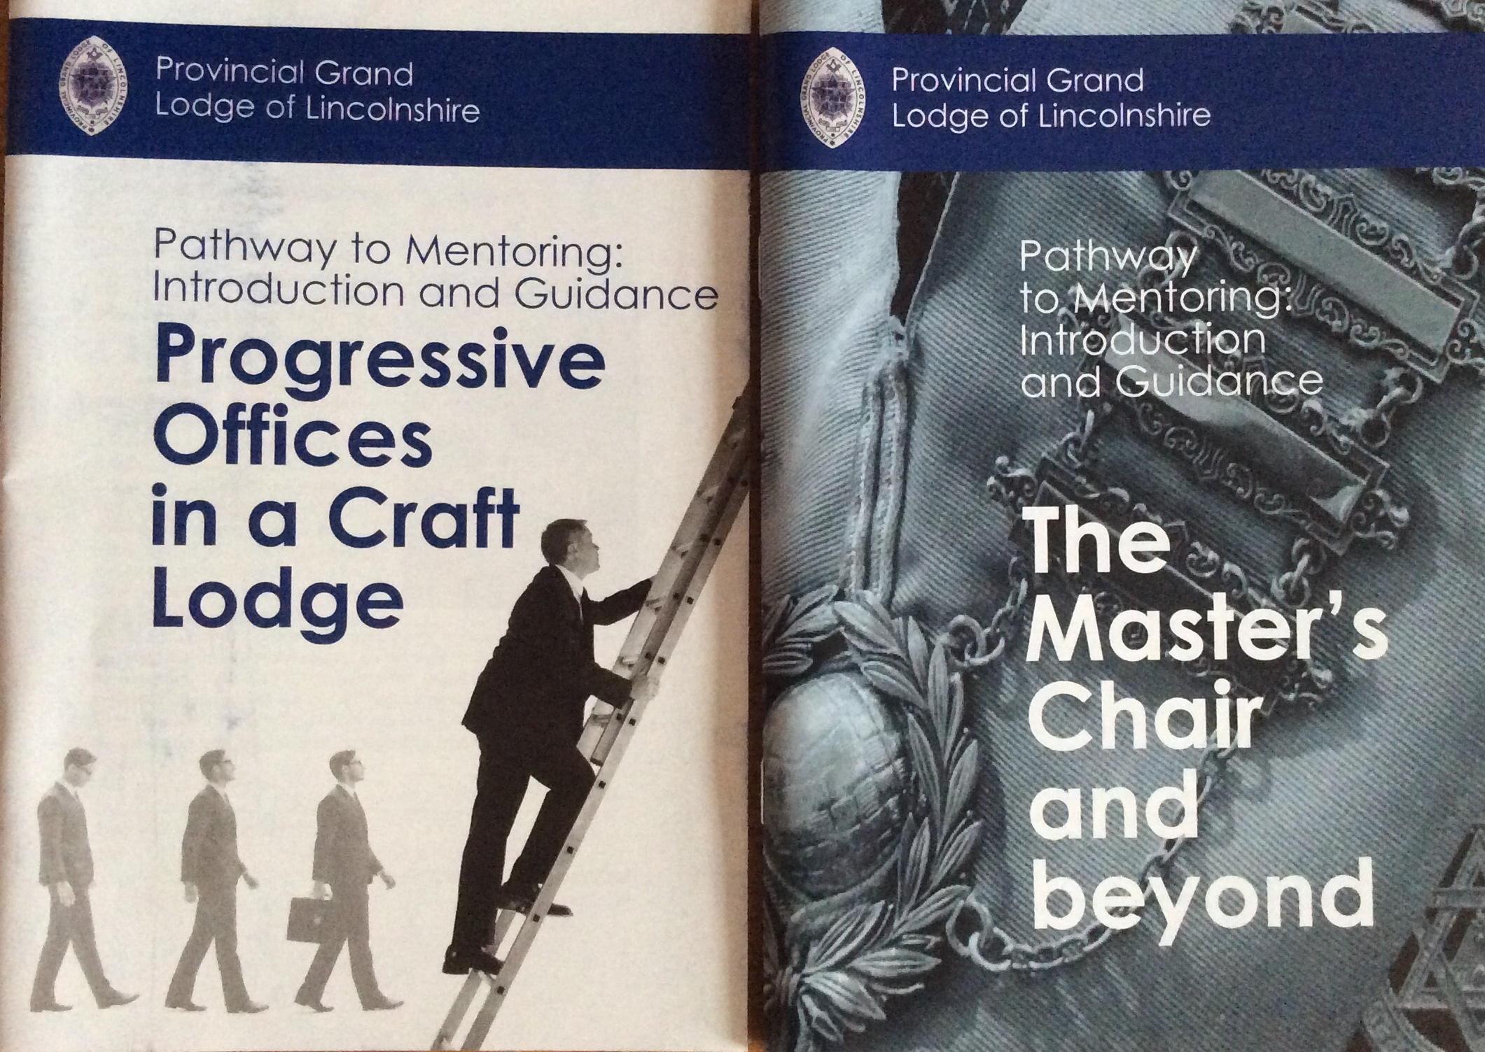

- These questions are in relation to the new updated ‘Members’ Pathway’ which has four main elements of Plan, Attract, Engage and Retrieve. Success relies on an effective ‘Lodge Membership Team’, consisting of a Membership Officer, Lodge Mentor, Almoner and others i.e., WM, DC, interested Lodge members. ‘Engage’ is the mentoring element.
- Are you familiar with the ‘Engage’ element?
- Does your Lodge have an active ‘Lodge Membership team’?
Yes/No If Yes, when was it established? Month______________ Year________
- Who are members of that team?
- How is Mentoring working as part of the Membership Challenge? (Give examples of any useful initiatives, if any. Continue on a separate sheet if necessary)

- Would you or your Lodge benefit from a presentation on the strategy/membership challenge/how to succeed/ Members’ Pathway

- Please give your general comments and any other observations you wish to make which would be helpful to the continued success/improvement of the Mentoring scheme. This includes comments on good practice, future requirements at Seminars/Workshops to assist you in your role, if appropriate.
Please continue on a separate sheet if necessary.

Signed – Lodge Mentor: |  | Date:
PLEASE NOTE: THIS FORM REQUIRES THE COMMENTS AND SIGNATURE OF THE LIAISON OFFICER (below)
BEFORE RETURNING TO THE PROVINCIAL GRAND MENTOR (address below)

Comments by Liaison Officer:

Please continue on a separate sheet if necessary.

Signed - Liaison Officer: |  | Date:

Please return to:
W.Bro Jason Fitzgerald via email; jjfitzgerald@virginmedia.com

